<https://www.experts-exchange.com/articles/12938/HOW-TO-Shrink-a-VMware-Virtual-Machine-Disk-VMDK-in-15-minutes.html>

before powering off vm we need to shrink space at OS level as allocated space.

Power OFF the Virtual Machine, and change to the datastore path where the VMware virtual machine disk (VMDK) is located.  
  
**cd /vmfs/volumes/<datastore name>/<VM foldername>**  
[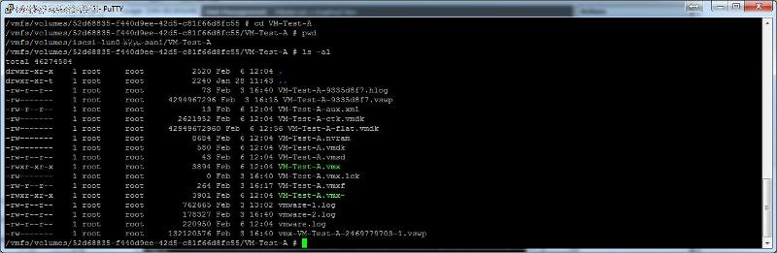](https://filedb.experts-exchange.com/incoming/2014/02_w06/832894/VM-Folder-Path.jpg)We need to edit the *.vmdk, which is the descriptor file, which contains the variables for the size of the *.-flat.vmdk. Using cat, this is what the descriptor file contains  
[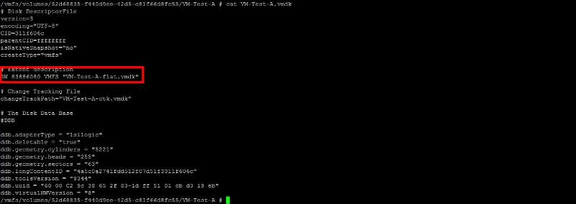](https://filedb.experts-exchange.com/incoming/2014/02_w06/832896/VMDK-Descriptor-file.jpg)The number highlighted above, under the heading #Extent description, after the letters RW, defines the size of the VMware virtual disk (VMDK).  
  
this number - 83886080, and it's calculated as follows:  
  
40 GB = 40 * 1024 * 1024 * 1024 / 512  =  83886080  
  
We wanted to reduce the size of the VMware virtual machine disk (VMDK) from 40 GB to 20 GB. So the value we need to enter into the descriptor file is:-  
  
20 GB = 20 * 1024 * 1024 * 1024 / 512  =  41943040  
  
Using vi, edit the descriptor file, and change the number from 83886080 to 41943040, and save the file.  
Migrate or Copy the virtual machine to another datastore,